Mallu Sravana Sandhya Assessment-8 12/12/2023

**PYTHON:**

* It is a high level language which is very easy to understand and syntax is very simple
* It is a free and open source programming language
* It is developed by Guido Van Rossum in late 1980s
* It is an interpreted and object oriented language
* It mainly depends on the index in the code
* It is an interpreted application we need not to be completed the whole code instead we will run in pieces and test for errors
* The python file should be saved with .py extension

**Features:**

* It is portable in any type of Operating System
* It is easily extendable
* It is scalable and can be adapted to any environment
* It is in interactive mode in testing and debugging
* It contains vast number of libraries which can be imported
* It takes care of memory allocation and deallocation(automatic garbage collection)
* It supports both functional and structural programming
* It supports graphical user interface
* It can be easily integrated to many no of codes
* It can support object oriented data
* It can be used to connect commercial databases

Python has vast development implementation in

* GUI
* Raspberry pi
* Audio
* Data science
* Business application
* Email
* Arduino interfacing
* Game development
* Symbolic mathematics etc..

Python also supports different frameworks like django, flask, pyramid, bottle, cherrypy, and so on

Python provides cross compilers to other languages like Cython, Jython, micropython,…..

Python under gone several versions since it was developed every year there is a small update in the python syntax or libraries or functions,..

As years go on new libraries are added to the python which makes us simple to perform operations

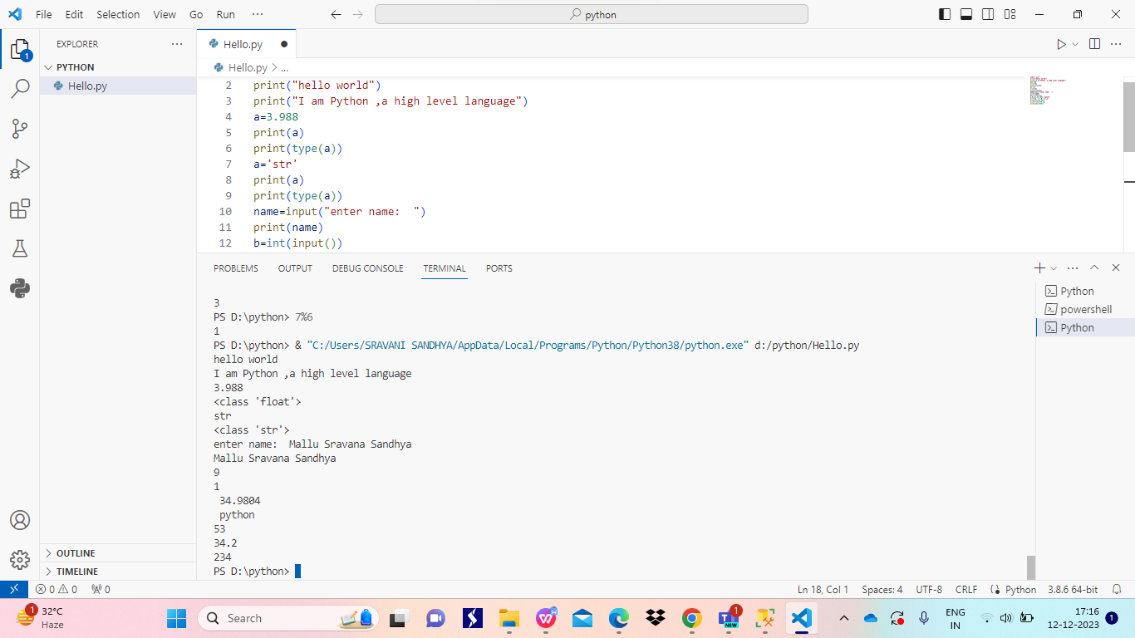

Some basic functions in python